***Gaurav Jain***

***Bachelor of Computer Applications***

***A/26***

***Thakur college of Engineering and Technology***

***Research paper about the futuristics AI techniques and Its uses.***

***Mentor :- Ms Rinkle Solanki***

**Title:** The Future of Nanotechnology, J.A.R.V.I.S.-Inspired AI, Iron Man Suits, Spider Web Technology, Interspecies Genetic Exchange, The great game Movie and use of high tech Technologies, and AV Screening in Mobile Devices

***

**Abstract**

This research paper explores the advancements in nanotechnology, AI-driven software like J.A.R.V.I.S., exoskeleton-based Iron Man suits, spider web technology, interspecies gene exchange, and the probability of humans developing spider-like abilities. Additionally, it covers the potential of AV screening technologies in mobile devices and the futuristic technologies showcased in the movie Ra.One. By analyzing scientific feasibility, ethical considerations, and future developments, this paper provides a deep insight into how these innovations may revolutionize defense, medicine, artificial intelligence, and consumer technology.

---

**1. Introduction**

Scientific advancements are breaking barriers between fiction and reality. Technologies that once belonged to movies and comic books are gradually becoming viable in real-world applications. From AI assistants to nanotechnology-driven exoskeletons, wearable tech, and bioengineering, our civilization is stepping closer to innovations resembling Iron Man suits, AI assistants like J.A.R.V.I.S., and even biological enhancements inspired by Spider-Man.

Moreover, the increasing integration of AV (augmented vision) screening technologies in mobile phones has drastically improved surveillance, health monitoring, and interactive applications. This paper deeply analyzes the potential of these innovations, their feasibility, and the challenges they present.

---

**2.** **Nanotechnology: Revolutionizing Wearable Systems and Material Science**

Nanotechnology is a multidisciplinary field dealing with the manipulation of matter at the molecular and atomic levels. It plays a crucial role in futuristic applications such as:

***2.1 Nano-Augmented Armor Materials***

- Lightweight and Durable: Carbon nanotubes and graphene composites enhance strength while maintaining flexibility.

- Self-Repairing Nanomaterials: Self-healing materials could allow battle suits or wearables to recover from damage in real time.

- Energy-Efficient Materials: Nanomaterials improve conductivity and battery efficiency, crucial for high-power exoskeletons.

***2.2 Biomimetic Nanorobotics***

- Bioengineered Nanobots: Microscopic robots can aid in tissue repair, drug delivery, and even cognitive enhancement.

- Adaptive Nano-Fibers: These could be used to create shape-shifting armor, allowing the user to adjust protective coverage dynamically.

***2.3 Nanotechnology in Medicine***

- Targeted Cancer Therapy: Nanoparticles are being developed to target cancer cells without harming healthy cells.

- Neural Implants: Nanotech-based brain-machine interfaces could enhance cognitive function, potentially leading to real-life superhuman abilities.

---

**3. AI-Driven Software: The Evolution of J.A.R.V.I.S. - Like Systems**

Artificial intelligence is progressing toward interactive, self-learning assistants. A J.A.R.V.I.S.-like system would integrate:

***3.1 Advanced Natural Language Processing (NLP)***

- Seamless human-AI interaction through real-time learning and contextual adaptation.

-Safer for all and maybe best for security purpose and confidential info cannot be breached out.

-Agenda made by these systems may helpful for the defence systems and safer for the units.

***3.2 Cybersecurity and Hacking Prevention***

- AI-powered self-learning encryption models ensure security against cyber threats.

-It can be advanced system which can talk back with us and secrucity is being controlled.

-Now, like Alexa,siri and Amazon echo the talkings can be recorded and can be used for manipulation or for several practices.

-Jarvis is an independent system which helps to solve basic problems and give solutions to any difficulties.

***3.3 Augmented Reality Interfaces***

- AI-driven Head-Up Displays (HUDs) could overlay real-time data for soldiers, engineers, and healthcare professionals.

-As it has talking back and reverting skills one can share thoughts and talk to it.

-Espically it is much helpul for kids and old ages as it signals to all family problem whether a problem is arise or not.

-The alarm or warn technologies is much helpful for it.

-It can helpful for the introvert kind of people.

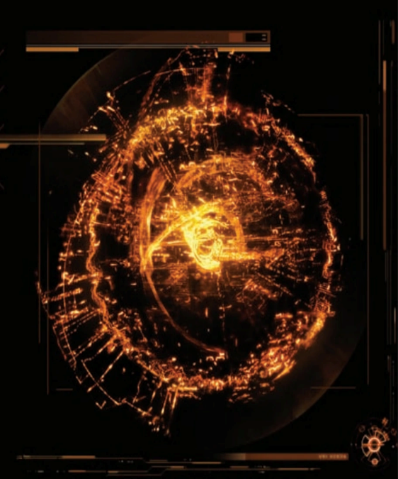

---

**4. The Iron Man Suit: Development of Exoskeletons and Wearable Flight Systems**

Exoskeleton-based technology is evolving rapidly, focusing on:

***4.1 Powered Exoskeletons***

- Military applications include strength augmentation and combat survivability.

- Medical applications help paraplegics regain mobility.

-Useful for the defence activities and much helpful for more power being source.

***4.2 Flight Propulsion Systems***

- Advanced jet propulsion systems that could be miniaturized for wearable flight capability.

-Helpful for single person life stakes and helpful in solving problems and clashes.

-It can be helpful in defence not only for countries but also for the whole world,as we can’t tell about the species that exist in other planets and how much they are ahead in technologies.

-It helps to bring the whole counry as a nation in diversified unity.

***4.3 Integrated AI & Smart Suits***

- Automated injury detection and biomonitoring for real-time health assessment.

-Helpful in emergency situations.

-Helful in wars,to help someone.

***4.4 The main body part***

-The main part of the whole suit can be determined as the arc reactor.

-As it functions the whole system in a easy and flexible way for any danger situation.

-It strengthen the heart by ages by using nitrogen oxide,by evolving the protons,neutrons and their properties.

-It increased the heart rate and its capacity to live much longer.

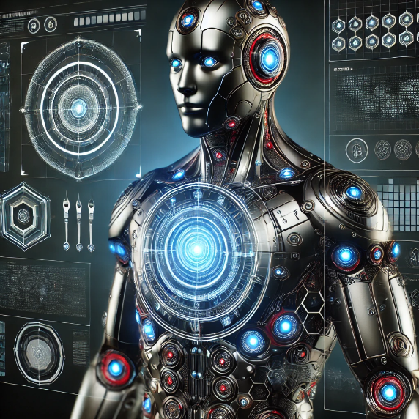

---

**5. Spider Web Technology: Strength, Applications, and Synthesis**

Spider silk is among the strongest biological materials, offering potential applications such as:

***5.1 Artificial Spider Silk Production***

- Bioengineered silk with enhanced tensile strength for military armor.

- Nanofiber-reinforced webs for medical sutures and flexible body armor.

***5.2 Spider strength and its flexibility***

-It helps to strengthen the capacity of body strength.

-It is helpful for flexibility to swing and helpful for the society.

-It increases the capacity to lift heavy equipment when needed.

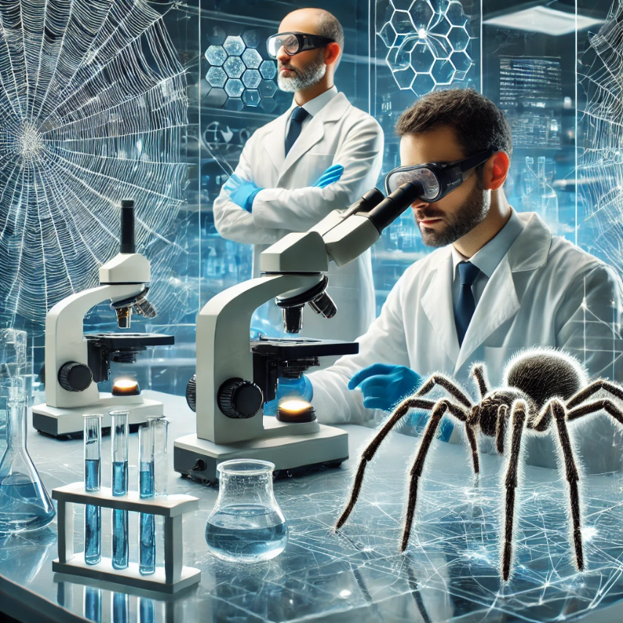

---

**6. The Theory of Interspecies Gene Exchange and the Possibility of Real Spider Powers**

Genetic engineering through CRISPR and other methods has led to experimental interspecies gene transfers:

***6.1 Feasibility of Spider-Human Genetic Integration***

- Gene editing using CRISPR to integrate spider-like traits into human DNA.

- Challenges: Immunological rejection, ethical concerns, and physiological incompatibility.

***6.2 Neuromuscular Adaptations for Enhanced Reflexes and Agility***

- Potential for neural modifications that enhance human speed and reaction times.

-Helps to modify the human strength by exchanging their habitats.

-Dolly the sheep was part of research to genetically modify farm animals, including introducing new genes to livestock. Dolly was the first mammal to be cloned from an adult cell, which was a scientific breakthrough.

-The genetic research of exchanging and inserting genes of two species had taken place in Russia for curing the cancer disease.

-On above of it,it can helps human being and human nature to be more improved,innovative and much powerful than it is today.

-The gene exchange taken place and test taken place on plants for make plants much powerful according to its capacities and removing the disadvantages and frail factors and making it useful for future scope.

---

**7. Ra.One Movie Technologies: AI-Powered Avatars and Virtual Reality Integration**

The Bollywood film Ra.One introduced several futuristic concepts:

***7.1 AI-Based Autonomous Avatars***

- Digital AI-driven entities that mimic human intelligence and decision-making.

-The real life gameplay characteristics which helps to be more magnificent and helpful in enjoying the real-life experiences.

-The technology used in the movie can be implemented on real basis and can be much easier for the human connections.

***7.2 Virtual Reality Combat & Training Simulations***

- VR-based combat simulations similar to Iron Man’s training in Marvel movies.

-Helpful in defence systems and for security purpose,which can be helpful for security purposes.

***7.3 Brain-Computer Interfaces***

- Future applications of neural link technologies to control virtual AI assistants.

-Smart enough to understand new ways of skills day-by-day for better reasons and better purposes.

-Helpful for maintaining the safety of all citizens and for reducing crimes in the world.

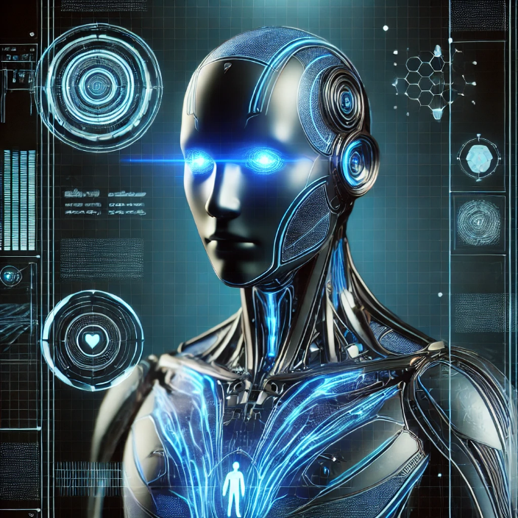

---

**8. Advanced Visual (AV) Screening Technologies in Mobile Devices**

Smartphones are evolving to incorporate sophisticated AV screening technologies:

***8.1 AI-Powered Biometric Authentication***

- Face and iris scanning for advanced security systems.

***8.2 Health Monitoring via AV Screening***

- Cameras capable of detecting vitals such as heart rate, skin conditions, and oxygen levels.

-Health check-ups can be much easier way of attaining via phones,New concept of tech is much useful in medicial fields making it much advanced.

***8.3 Augmented Reality for Real-Time Data Analysis***

- Applications in education, security, and professional fields.

-It shows a impact of the iron-man movie,the advanced av based mobile phone and its uses.

-It helps to work as a group project,it can be much helpful to students for group project seeing a similar content on a same device and also a small and portable device which can be carried.

-It can be installed in a such a way to put a impact on the new technologies in the smart phones making it much and more smart and capable for holding such capability.

-Completing a group project by just seeing the same content inspite of an AV to an phone which can be hold itself as an AV is much easier and affordable.

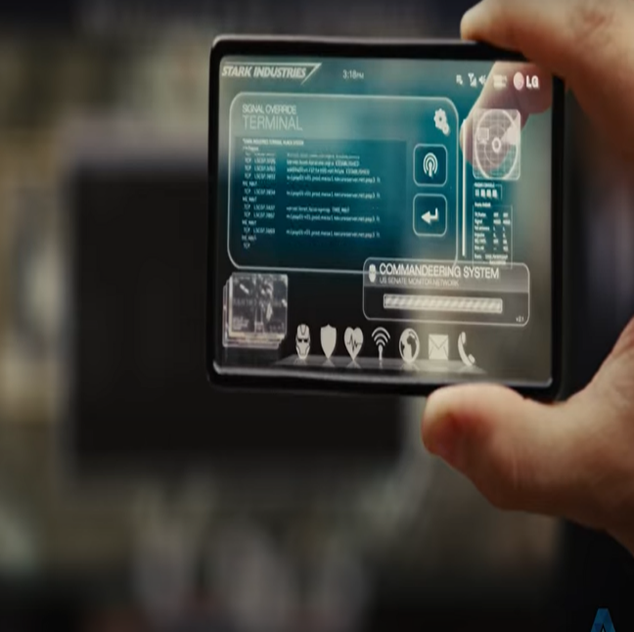 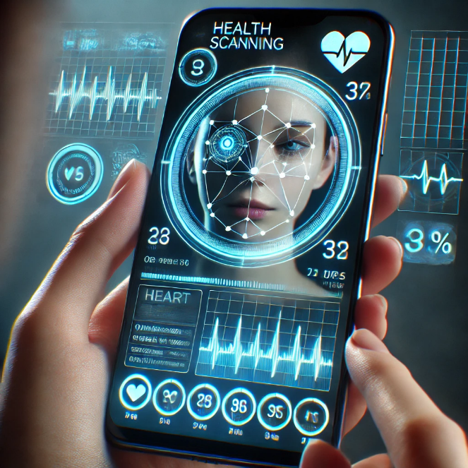

---

**9. Conclusion**

While a fully functional Iron Man suit, real-life Spider-Man abilities, and Ra.One - like AI avatars remain speculative, advancements in nanotechnology, AI, bioengineering, and material science suggest that certain elements of these concepts may become reality. Continued research, responsible innovation, and ethical considerations will shape the future of these transformative technologies.And with these technologies which can be much stronger and helpful for several other and may be much better than we are and also be supportive towards all.

---

**References**

(A comprehensive list of academic, industry, and technological sources related to nanotechnology, AI, exoskeletons, genetic modification, spider silk, AV screening technologies, and AI-driven avatars.)

**Thank**

**You**